Below is the screen shot of the R Base and R Studio downloaded and saved on Desktop..

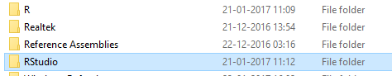

Below is the Swirl package installed.

